Packet Tracer - Basic Switch and End Device Configuration - Physical Mode

LAB # 08



Spring 2024
CSE-303L Data Communication & Networks Lab

Submitted by: Ali Asghar
Registration No.: 21PWCSE2059
Class Section: C

“On my honor, as student of University of Engineering and Technology, I have neither given nor received unauthorized assistance on this academic work.”

Submitted to:
Dr. Yasir Saleem Afridi

Date:
15th June 2024

Department of Computer Systems Engineering
University of Engineering and Technology, Peshawar

CSE 303L: Data Communication and Computer Networks
Demonstration of Concepts | Poor (Does not meet expectation (1))  The student failed to demonstrate a clear understanding of the assignment concepts | Fair (Meet Expectation (2-3))  The student demonstrated a clear understanding of some of the assignment concepts | Good (Exceeds Expectation (4-5)  The student demonstrated a clear understanding of the assignment concepts | Score  30%
Accuracy | The student mis-configured enough network settings that the lab computer couldn't function properly on the network | The student configured enough network settings that the lab computer partially functioned on the network | The student configured the network settings that the lab computer fully functioned on the network | 30%
Following Directions | The student clearly failed to follow the verbal and written instructions to successfully complete the lab | The student failed to follow the some of the verbal and written instructions to successfully complete all requirements of the lab | The student followed the verbal and written instructions to successfully complete requirements of the lab | 20%
Time Utilization | The student failed to complete even part of the lab in the allotted amount of time | The student failed to complete the entire lab in the allotted amount of time | The student completed the lab in its entirety in the al | 20%
Credit Hours: 1

Topology
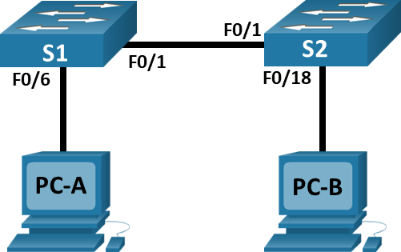

Addressing Table
Device | Interface | IP Address | Subnet Mask
S1 | VLAN 1 | 192.168.1.1 | 255.255.255.0
S2 | VLAN 1 | 192.168.1.2 | 255.255.255.0
PC-A | NIC | 192.168.1.10 | 255.255.255.0
PC-B | NIC | 192.168.1.11 | 255.255.255.0
Blank Line - no additional information

Objectives
Part 1: Set Up the Network Topology
Part 2: Configure PC Hosts
Part 3: Configure and Verify Basic Switch Settings

Background / Scenario
In this Packet Tracer Physical Mode (PTPM) activity, you will build a simple network with two hosts and two switches. You will also configure basic settings including hostname, local passwords, and login banner. Use show commands to display the running configuration, IOS version, and interface status. Use the copy command to save device configurations.
You will apply IP addressing for to the PCs and switches to enable communication between the devices. Use the ping utility to verify connectivity.

Packet Tracer - Basic Switch and End Device Configuration - Physical Mode

Instructions

Part 1: Set Up the Network Topology
Power on the PCs and cable the devices according to the topology. To select the correct port on a switch, right click and select Inspect Front. Use the Zoom tool, if necessary. Float your mouse over the ports to see the port numbers. Packet Tracer will score the correct cable and port connections.
- There are several switches, routers, and other devices on the Shelf. Click and drag switches S1 and S2 to the Rack. Click and drag two PCs to the Table.
- Power on the PCs.
- On the Cable Pegboard, click a Copper Cross-Over cable. Click the FastEthernet0/1 port on S1 and then click the FastEthernet0/1 port on S2 to connect them. You should see the cable connecting the two ports.
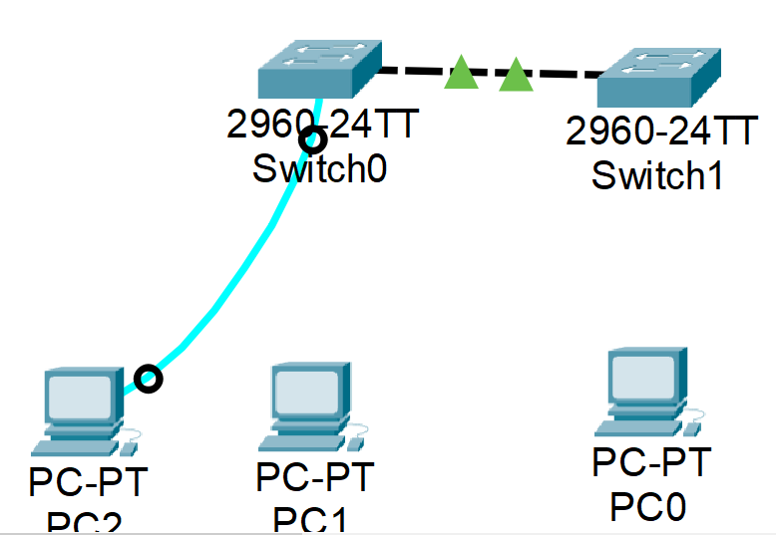

- On the Cable Pegboard, click a Copper Straight-Through cable. Click the FastEthernet0/6 port on S1 and then click the FastEthernet0 port on PC-A to connect them.
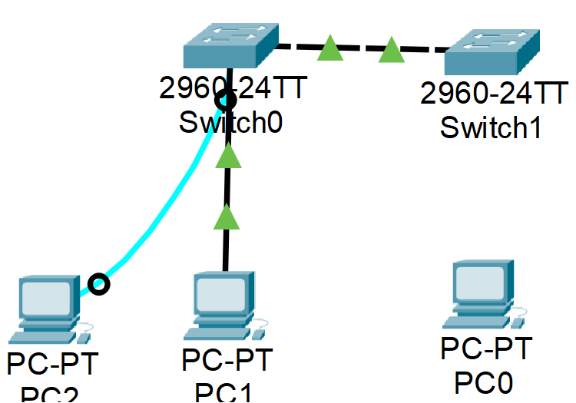
- On the Cable Pegboard, click a Copper Straight-Through cable. Click the FastEthernet0/18 port on S2 and then click the FastEthernet0 port on PC-B to connect them.
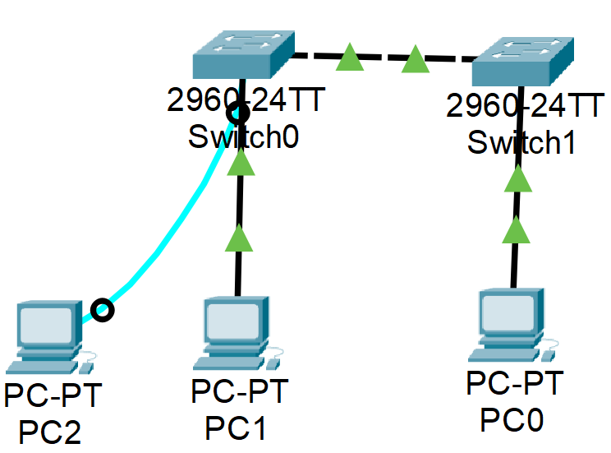

- Visually inspect network connections. Initially, when you connect devices to a switch port, the link lights will be amber. After a minute or so, the link lights will turn green.

Part 2: Configure PC Hosts
Configure static IP address information on the PCs according to the Addressing Table.
- Click PC-A > Desktop > IP Configuration. Enter the IP address for PC-A (192.168.1.10) and the subnet mask (255.255.255.0), as listed in the IP addressing table. You can leave default gateway blank at this time because there is no router attached to the network.
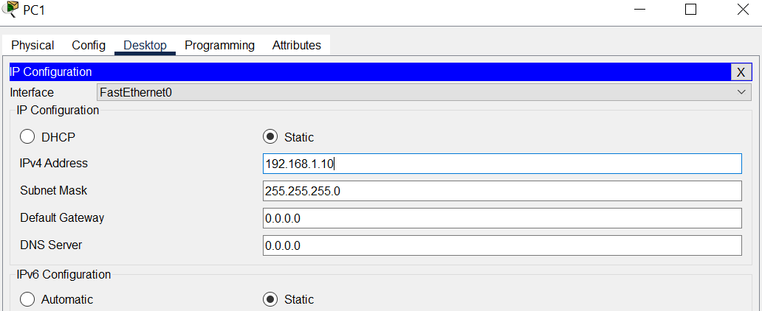

- Close the PC-A window.
- Repeat the previous steps to assign the IP address information for PC-B, as listed in the Addressing Table.
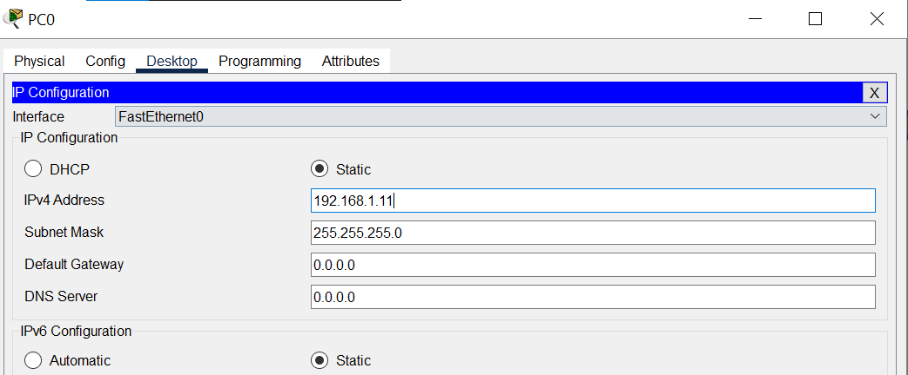

- Click PC-A > Desktop > Command Prompt. Use the ipconfig /all command at the prompt to verify settings.
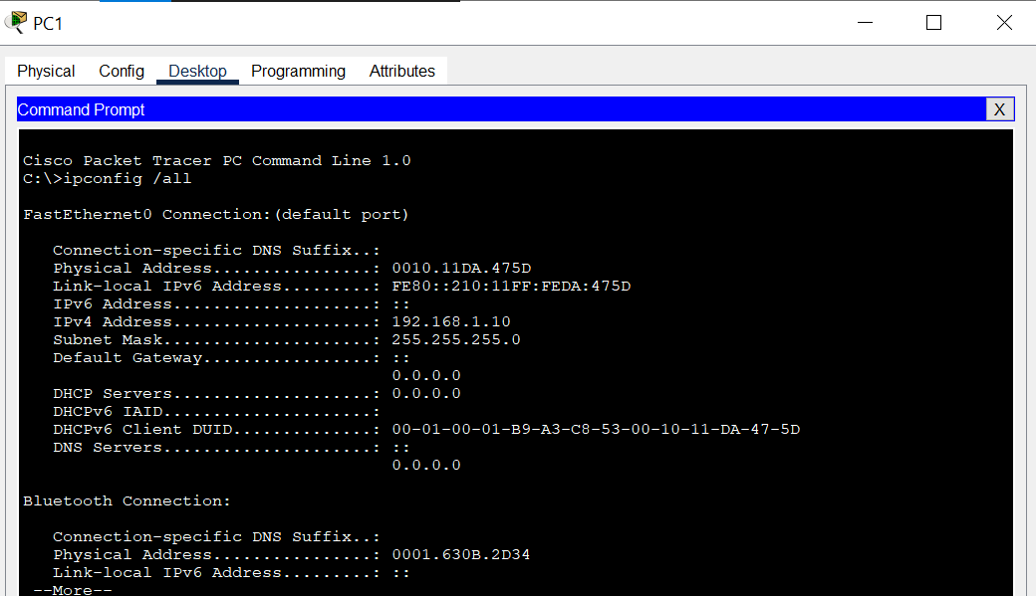

- Enter ping 192.168.1.11 at the prompt to test the connectivity to PC-B. The ping should be successful, as shown in the following output. If the ping is not successful, check the configurations on both of the PCs and troubleshoot as necessary.

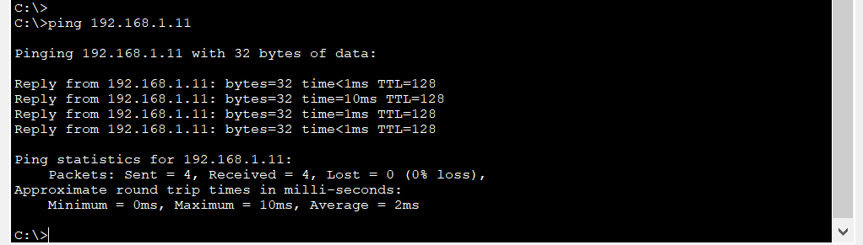
Packet Tracer - Basic Switch and End Device Configuration - Physical Mode

C:\>

Part 3: Configure and Verify Basic Switch Settings
- On the Cable Pegboard, click a Console cable. Connect the console cable between S1 and PC-A.
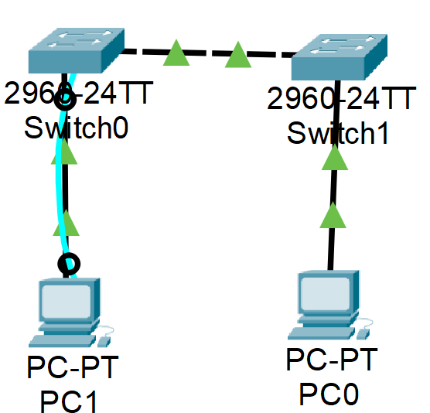

- Establish a console connection to the switch S1 from PC-A using the Packet Tracer generic Terminal program (PC-A > Desktop > Terminal). Press ENTER to get the Switch> prompt.
- You can access all switch commands in privileged EXEC mode. The privileged EXEC command set includes those commands contained in user EXEC mode, as well as the configure command through which access to the remaining command modes are gained. Enter privileged EXEC mode by entering the enable command.

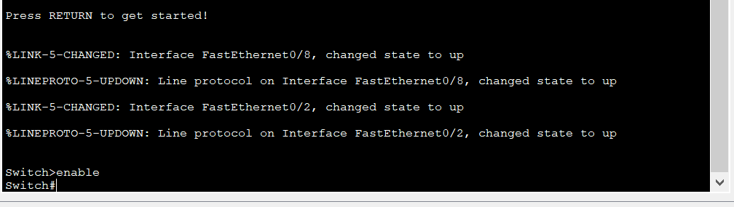
Open Configuration Window
- The prompt changed from Switch> to Switch# which indicates privileged EXEC mode. Enter global configuration mode.
- The prompt changed to Switch(config)# to reflect global configuration mode. Give the switch a name according to the Addressing Table.
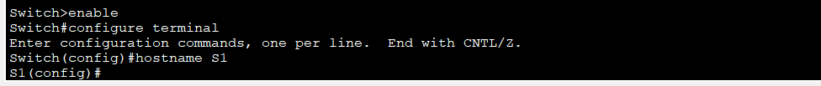

- Enter local passwords. Use class as the privileged EXEC password and cisco as the password for console access.
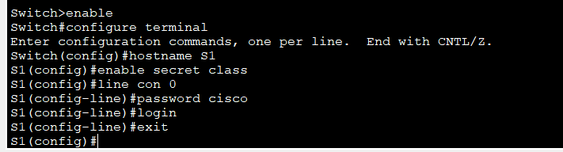

- Configure and enable the VLAN 1 interface according to the Addressing Table.
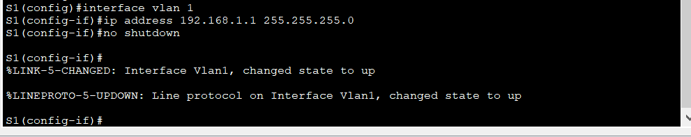

- A login banner, known as the message of the day (MOTD) banner, should be configured to warn anyone accessing the switch that unauthorized access will not be tolerated. Configure an appropriate MOTD banner to warn about unauthorized access.
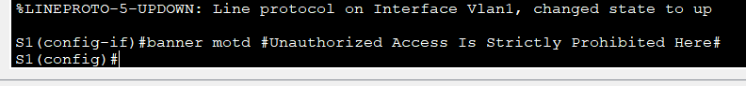

- Save the configuration to the startup file on non-volatile random access memory (NVRAM).
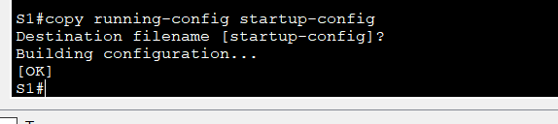
- Display the current configuration.
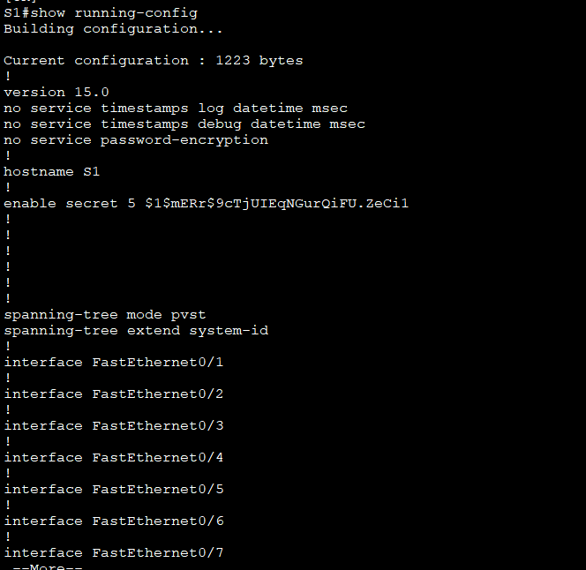
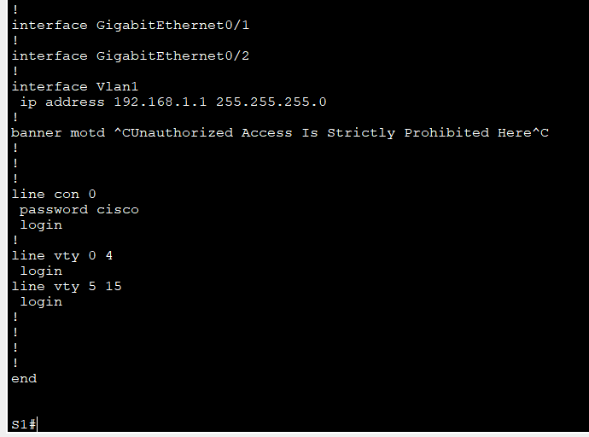

- Display the IOS version and other useful switch information.
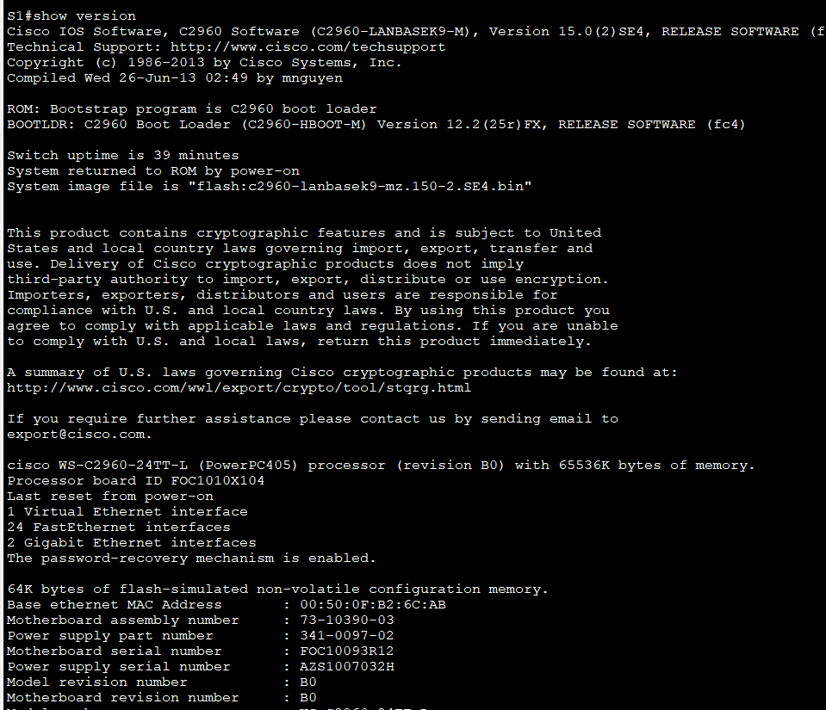
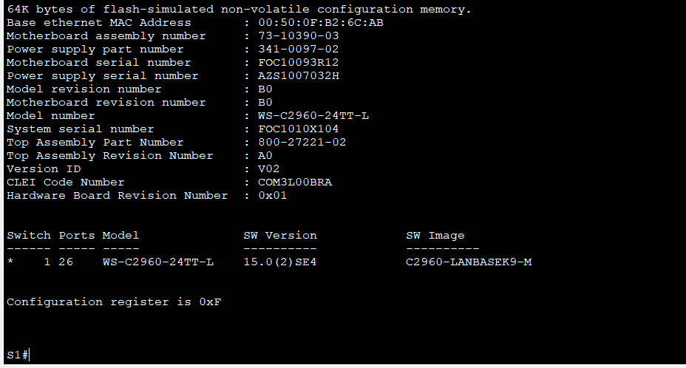

- Display the status of the connected interfaces on the switch.
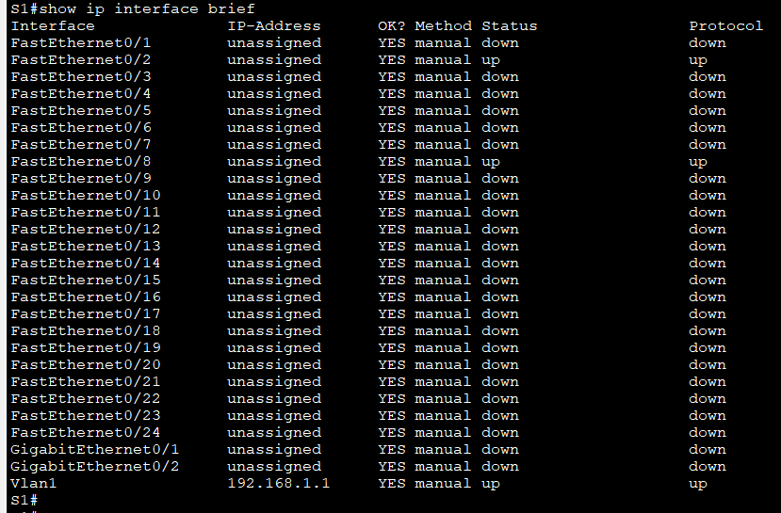
Close Configuration Window.
- Repeat the previous steps to configure switch S2. Make sure the hostname is configured as S2.
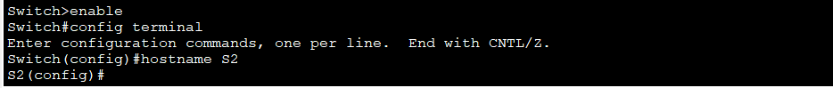
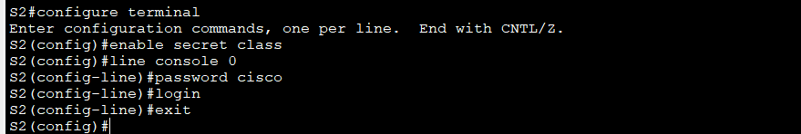
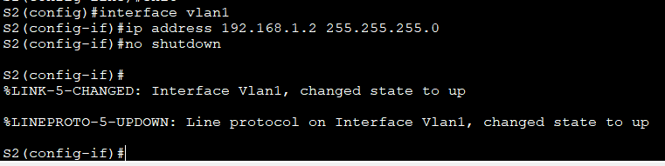
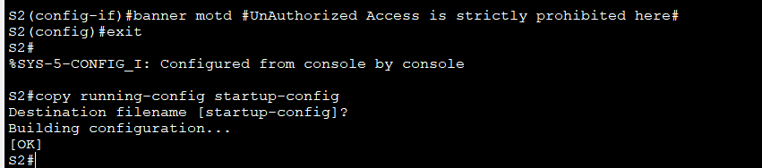
- Record the interface status for the following interfaces.
Interface | S1 Status | S1 Protocol | S2 Status | S2 Protocol
F0/1 | up | up | up | up
F0/6 | up | up | down | down
F0/18 | down | down | up | up
VLAN 1 | up | up | up | up
Blank Line - no additional information
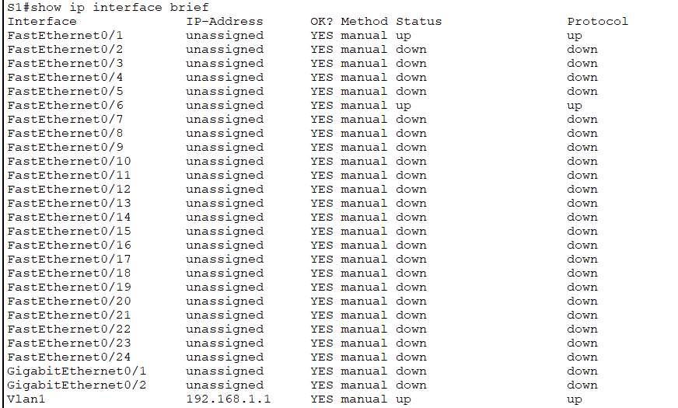
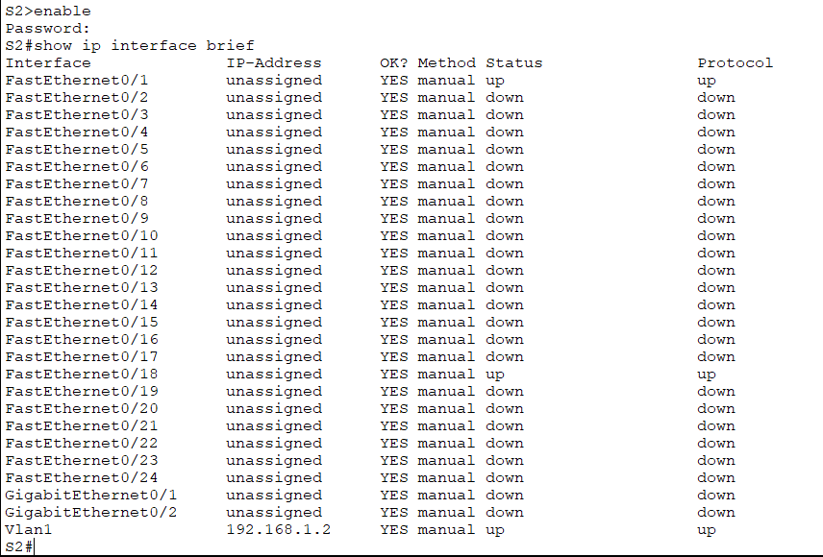
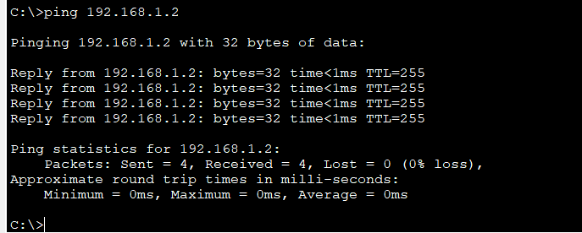
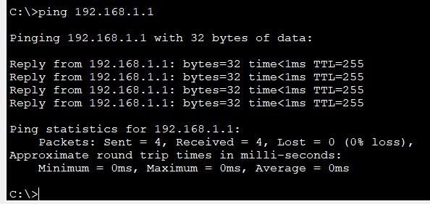
- From a PC, ping S1 and S2. The pings should be successful.

Pinged from PC-A

- From a switch, ping PC-A and PC-B. The pings should be successful.
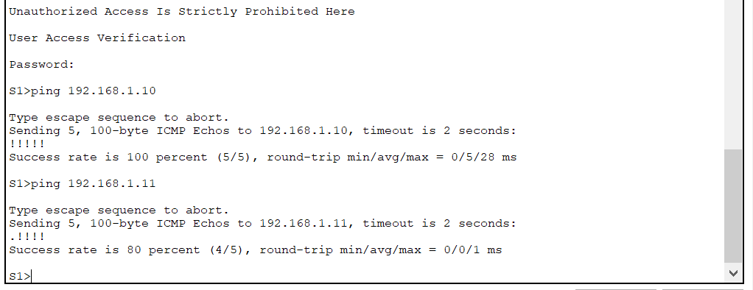

Reflection Question
Why are some FastEthernet ports on the switches up while others are down?
Ans: Because these ports are connected through cables
What could prevent a ping from being sent between the PCs?
Ans: Following scenarios could prevent a ping from being sent between the PCs.
- Wrong IP address
- media disconnected
- switch powered off
- ports administratively down
- firewall.
End of Document

